S. No | Title | Description | Page No.
1 | Introduction | Overview of the project and its purpose | 1
2 | Objectives of the Project | Goals and aims of developing the portal | 3
3 | System Requirements | Hardware and software requirements | 5
4 | Technologies Used | Tools, languages, and frameworks used | 7
5 | System Architecture | Django MVT structure and workflow overview | 9
6 | Database Design | Details of tables and fields used | 11
7 | System Modules | Different modules of the portal and their functions | 13
8 | Key code&System outputs | Screens, code, and sample outputs | 15
9 | Advantages and Future Enhancements | Benefits of the system and possible improvements | 29
10 | Conclusion | Summary and final remarks | 31
INDEX

INTRODUCTION

The Job Application Portal is a web-based application developed using the Django framework. The purpose of this system is to simplify the process of submitting job applications online. Instead of sending resumes or personal information through emails or physical forms, applicants can fill out a simple online form.
The portal collects important details such as the applicant’s name, email address, available start date, and current occupation. Once the form is submitted, the data is stored in a database and a confirmation email is automatically sent to the applicant.
This project demonstrates how Django can be used to create a simple yet effective web application that handles user input, stores information in a database, and communicates with users through automated emails.

OBJECTIVES OF THE PROJECT

The main objective of developing the Job Application Portal is to create a simple and efficient platform that allows users to submit job applications online. In many organizations, collecting applications through emails or manual forms can make it difficult to organize and manage applicant data. This system aims to simplify that process by providing a centralized web application where users can easily submit their details through an online form.
Another objective of the project is to store applicant information securely in a database and ensure that the submitted data can be easily managed by administrators. The system also aims to provide an automatic email confirmation feature so that applicants receive a notification once their application has been successfully submitted.
Additionally, this project helps in understanding the practical implementation of Django web development concepts, including models, views, templates, and form handling. It also demonstrates how backend logic and frontend interfaces work together to build a functional web application.

SYSTEM REQUIREMENTS

Hardware Requirements
- Processor: Intel Core i3 or higher
- RAM: Minimum 4 GB
- Hard Disk: 500 GB or more

Software Requirements
- Operating System: Windows / Linux / MacOS
- Programming Language: Python
- Framework: Django
- Frontend: HTML, CSS, Bootstrap
- Database: SQLite
- Browser: Chrome, Firefox, or Edge
- Code Editor: Visual Studio Code / PyCharm

TECHNOLOGIES USED

Technology | Purpose
Python | Backend programming language
Django | Web framework used to build the application
HTML | Structure of web pages
CSS | Styling of the user interface
Bootstrap | Responsive web design
SQLite | Database for storing application data

SYSTEM ARCHITECTURE

The project follows Django’s Model–View–Template (MVT) architecture.
Model:
The model defines the structure of the database and stores the applicant information such as name, email, available date, and occupation.
View:
Views handle the application logic. They process form submissions, validate user input, save the data in the database, and send confirmation emails.
Template:
Templates are responsible for displaying the user interface using HTML, CSS, and Bootstrap

DATABASE DESIGN

The system uses SQLite as the database to store application data.
The main table used in the project is called Form, which stores the applicant information.
Field | Description
first_name | Applicant’s first name
last_name | Applicant’s last name
email | Applicant’s email address
date | Available start date
occupation | Current occupation
Whenever a user submits the application form, these details are stored in the database.

SYSTEM MODULES

The system is divided into several modules that work together to complete the application process.
About Module:
Displays information about the job portal and its purpose.
Application Form Module:
Allows users to fill in their personal details and submit the job application.
Database Module:
Stores applicant information securely in the SQLite database.
Email Notification Module:
Sends confirmation emails to applicants and notifications to the administrator.
Admin Module:
Allows administrators to view and manage submitted applications through the Django admin panel.

KEY CODE &SYSTEM OUTPUT

#index.html (This file creates the Job Application Form interface for the user.)
{% extends 'base.html' %} {% block content %}
<h1 class="mt-4 mb-4">Job Application Form</h1>
<form method="post">
{% csrf_token %}
<input type="text" name="first_name" placeholder="First Name" required>
<input type="text" name="last_name" placeholder="Last Name" required>
<input type="email" name="email" placeholder="Email" required>
<input type="date" name="date" required>
<button type="submit">Submit</button></form>
{% endblock %}
#Forms.py (This file defines the form structure used to collect user input from the website.)
from django import forms
class ContactForm(forms.Form):
"""Form for job application input Mirrors the Model structure but for frontend"""
first_name = forms.CharField(max_length=80)
last_name = forms.CharField(max_length=80)
email = forms.EmailField()
date = forms.DateField()
occupation = forms.CharField(max_length=80)
#models.py (This file defines the database structure used to store job applicant information.)
from django.db import models
class Form(models.Model):
"""Job Application Form Model Stores applicant information """
first_name = models.CharField(max_length=80)
last_name = models.CharField(max_length=80)
email = models.EmailField()
date = models.DateField()
occupation = models.CharField(max_length=80)
def __str__(self):
"""String representation of the model Displays in admin panel """
return f"{self.first_name} {self.last_name}"

#views.py (This file contains the application logic, handles form submission, saves data to the database, and sends confirmation emails.)
from django.shortcuts import render
from .forms import ContactForm
from .models import Form
from django.contrib import messages
from django.core.mail import EmailMessage
def index(request):
"""Handle form submission"""
if request.method == 'POST':
form = ContactForm(request.POST)
if form.is_valid():
first_name = form.cleaned_data['first_name']
last_name = form.cleaned_data['last_name']
email = form.cleaned_data['email']
date = form.cleaned_data['date']
occupation = form.cleaned_data['occupation']
Form.objects.create(
first_name=first_name,
last_name=last_name,
email=email,
date=date,
occupation=occupation )
my_mail="kumar425879@gmail.com"
msg_body = f"Available date:{date}\nYour job application was submitted.\nThank You {first_name} {last_name}!"
email_msg = EmailMessage(
"Job application Submission Confirmation",
msg_body,
to=[email],
bcc=[my_mail],
)
msg_body=f"Name:{first_name},\n Date:{date},\n Occupation:{occupation}"

em=EmailMessage(
"INFO:-",
msg_body,
to=[my_mail], )
email_msg.send()
em.send()
messages.success(request, "Form Submitted Successfully!")
return render(request, "index.html")
def about(request):
"""Render about page"""
return render(request, "about.html")

OUTPUTS:
About Page:
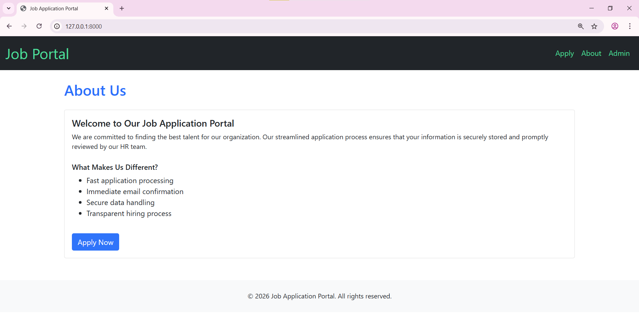

Application Page:
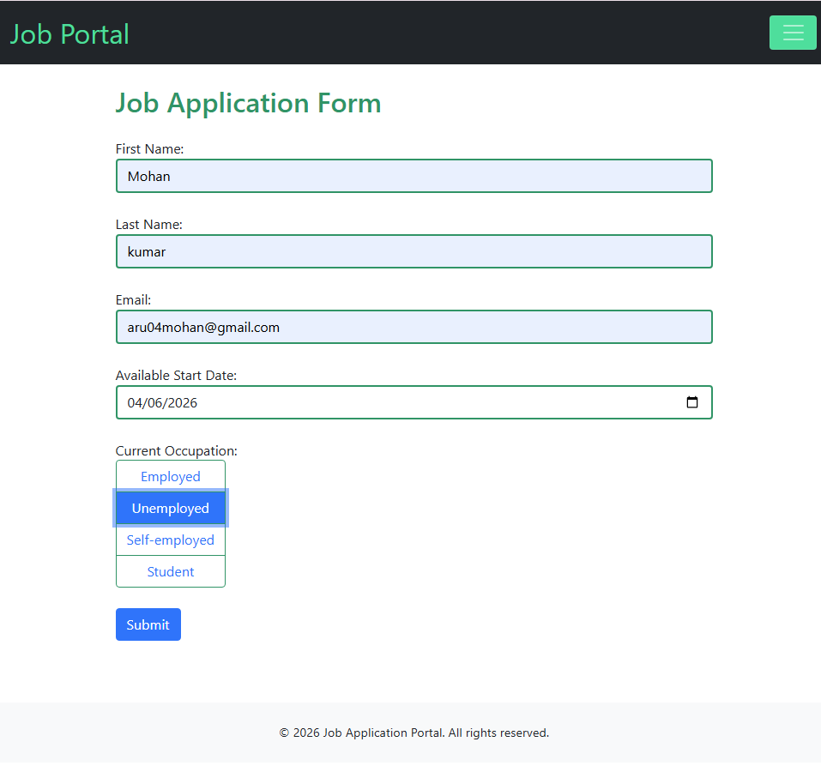
Success Message:
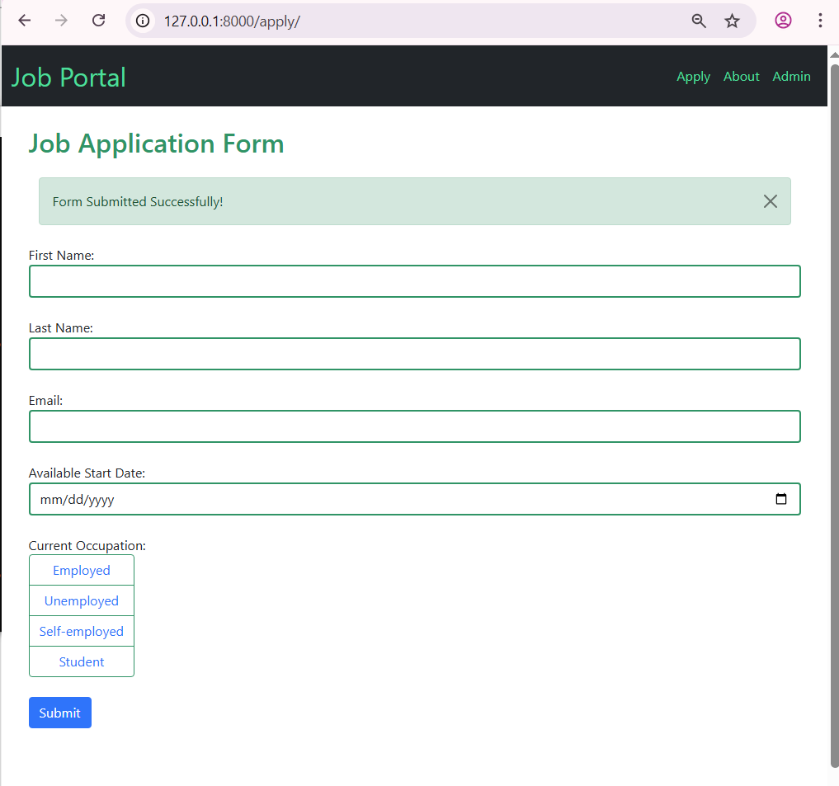

Admin Page:
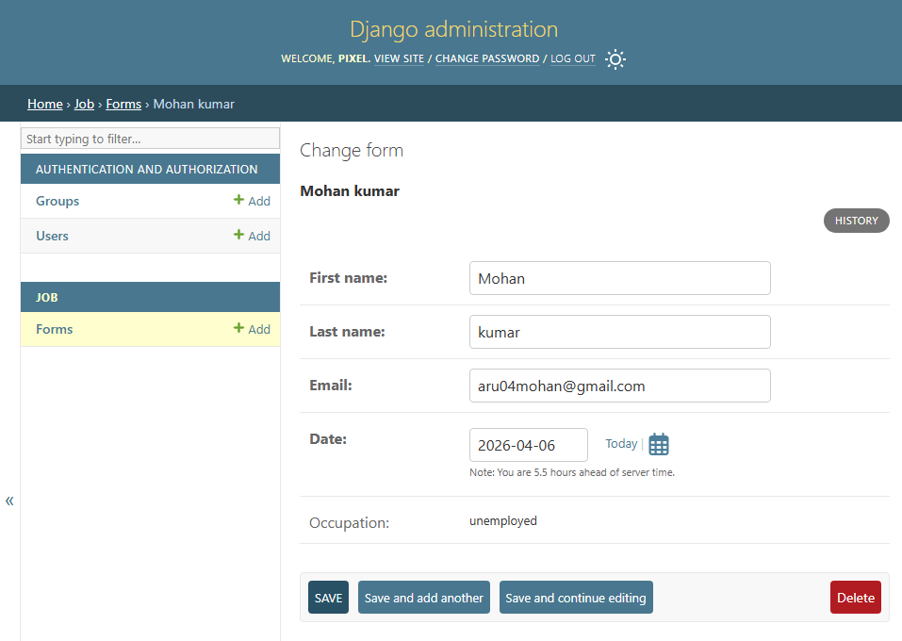
Thank you Mail(To the Applicant):
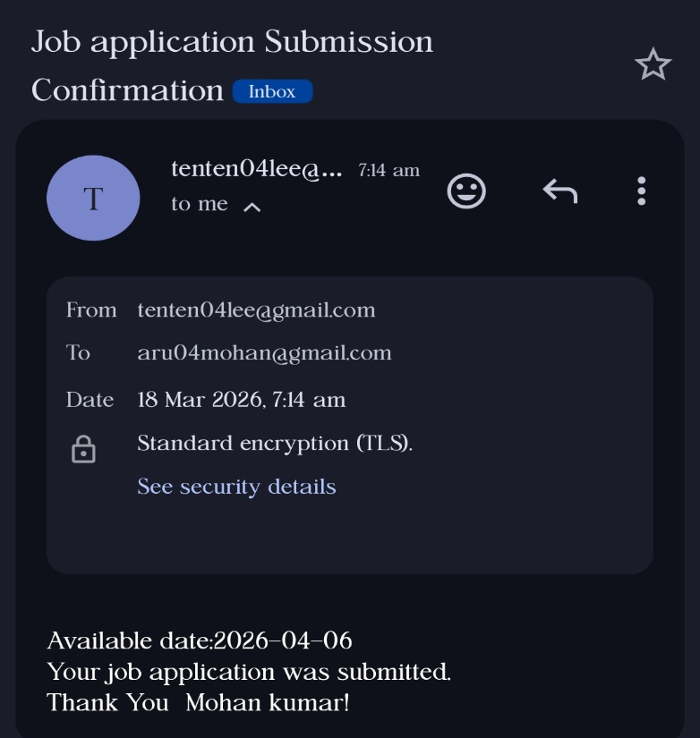

Information Mail(To the Admin):
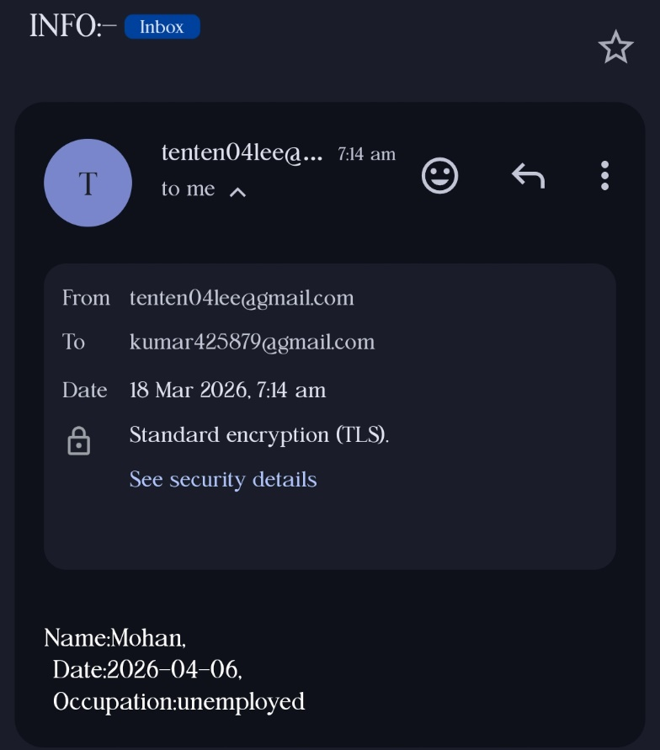

ADVANTAGES AND FUTURE ENHANCEMENTS

Advantages:
- Easy and convenient job application process
- Automatic email confirmation after submission
- Secure storage of applicant data
- Simple and user-friendly interface
- Admin panel for managing applications

Future Enhancements:
The system can be improved by adding features such as:
- Resume or document upload
- Multiple job listings
- User login and registration
- Application status tracking
- Advanced admin dashboard

CONCLUSION

The Job Application Portal using Django is a simple web application designed to make the job application process easier and more organized. It allows applicants to submit their information through an online form and ensures that the data is securely stored in the database.
The project demonstrates how Django can be used to develop a web application that integrates form handling, database management, and email functionality. It also provides practical experience in building full-stack web applications using Python and modern web technologies.
Overall, the project successfully achieves its goal of creating an efficient and user-friendly job application system.

